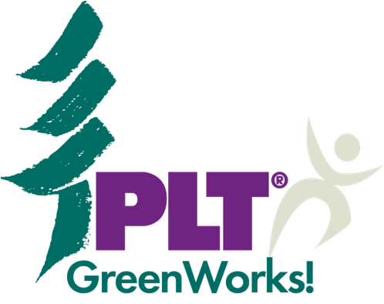
2012
Grant Application

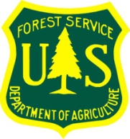

Project Learning Tree’s GreenWorks! grant program is changing and growing
in proud partnership with the USDA Forest Service.

In 2012, Project Learning Tree (PLT) is pleased to announce that grants are available in two award levels: 1) the popular and traditional GreenWorks! grants up to a maximum of $1,000 and 2) GreenWorks! grants up to $3,000 for registered PLT GreenSchools! (free online registration!)

Project proposals are due September 30th, 2012, and funds will be distributed in December for project implementation throughout the 2013 calendar year. To apply for a PLT GreenWorks! service-learning grant, please complete this form in its entirety.

Submission Instructions: Submit your completed application online. Login or create an account, click “Apply for a Grant,” then follow the prompts to complete your submission. Contact Kyle Cooper at kcooper@plt.org or 202-463-2475 with any questions. No hard copy applications will be accepted.
Part I: Applicant Information
Which grant level you are applying for? (check appropriate box)

  - We are a applying for a traditional GreenWorks! grant of up to $1,000

  - We are a registered PLT GreenSchool! applying for a grant of up to $3,000

Contact Name

Title

School/Organization Name

School/ Organization Address

City State Zip

Email Phone

Alternate Email (required)
Part I: Applicant Information (continued)
Tax Information (Required)

As mandated by Project Learning Tree’s auditing procedures, all applicants must submit a W-9 form for their school or organization. You can visit the Internal Revenue Service website to download a free W-9 Form.

Please save, complete, and submit the W-9 Form electronically, along with this grant application.
Applications without accompaniment of a W-9 Form will not be considered.

Indicate your school or organization’s
employer identification number (EIN),
taxpayer identification number (TIN),
federal identification number, or similar (Tax ID Number)
on the line provided expressed in the
following format: XX-XXXXXXX

Is your school or organization a tax exempt entity
under the Internal Revenue Code (IRC)? (Yes or No)
If so, what code section?
Example: 501(c)(3) (IRC code section)

Was a W-9 Form submitted with this grant application?
(Yes or No)

Part II: Grant Requirements Enter Yes or No

- Have you attended a Project Learning Tree (PLT) workshop¹?
If yes, indicate the state and year²:

- Is this project a service-learning experience?

- Does this project exemplify student voice³?

- Does this project involve local community partners?

- Have you secured 50 percent matching funds for your project?
(some of which may be in-kind services/time)

Answer questions 6-10 only if you are a registered PLT GreenSchool! and intend to apply for a grant up to $3,000. Proceed to part III if you are applying for a traditional GreenWorks! grant.

- Is your institution a formal school⁴ (public or private)?

- Is your school registered on the PLT GreenSchools! website?

- Has your school established a Green Team⁵ consisting of students,
teachers, and school staff?

- Has your school completed one or more of the PLT GreenSchools!
Investigations⁶?

10. Is this project based on the results and findings of one or more of the
PLT GreenSchools! investigations?

- PLT workshops are organized on a state-by-state basis. Contact your local PLT State Coordinator to register for a workshop in your area. Call 202-463-2475 or visit www.plt.org to obtain their contact information.
- Applicants must have attended OR be registered to attend a PLT workshop by September 30, 2012.
- Student voice allows for youth to express their opinions and make decisions regarding the planning, implementation, and evaluation of their learning experiences, as defined by Rogers, A. (2005) in Student voice: Bridges to learning.
- All grade levels (preK-12) are welcome to apply, however only formal schools (public or private) are eligible for grants up to $3,000.
- Details on establishing a Green Team can be found after registering at www.greenschools.org.
- The five PLT GreenSchools! investigations can be downloaded after registering at www.greenschools.org. Each investigation has a section for gathering ideas on action projects.
Part III: Project Overview

- Project Title:

- Project Type (e.g. school recycling, site restoration, energy conservation, etc.):

3. Grade level(s) involved:

4. Number of students involved:

5. If awarded, make the grant check payable to: ____________________________
Note: The recipient must be a school or organization; not an individual’s name.

6. Project Abstract: Briefly describe your project using 100 words or less.

7. Amount requested: $ Acquired matching funds: $

Part IV: Project Narrative

- Provide a detailed narrative that describes the proposed project that explains the logistics and details related to who, what, where, when, why, and how. (If you are a GreenSchool! applying for a grant of up to $3,000, please also describe how the proposed action project was identified through conducting one of the GreenSchools! investigations.)
Limit: 500 Words

- Describe how your project exemplifies student voice. How will students be involved in the planning and implementation of the project? How will this project enhance student leadership skills?
Limit: 250 Words

- Explain how the project exemplifies service-learning through its connection to academic curricula. What community or school need does this project address? How will students learn from the project? How will this project be tied to academic content standards (if applicable)? What specific PLT activities will be used in the environmental education efforts that accompany this project?
Limit: 250 Words

- List and describe the role of community partner organizations involved in the project.
Limit: 250 Words

- Provide a project timeline, which includes anticipated commencement and completion dates. Note: Funds will be available to awarded projects in early 2013.
Limit: 250 Words

- Describe your plan to inform the public and local officials about your project’s accomplishments. For example, you may write press releases for local media, send volunteer day invitations to your school board, city, and government officials, and/ or submit articles to National PLT and other project partners for newsletters, websites, and social media.
Limit: 250 Words

Part V: Budget

Use the table below to provide an itemized project budget. Note that funds may NOT be used to cover salaries, consulting fees, indirect administrative costs, shipping, electronic equipment, or field trip travel.

Expenses | Funds Requested | Matching Funds | Source of Matching Funds | Total  (Requested + Matching Funds)
 | $ | $ |  | $
 | $ | $ |  | $
 | $ | $ |  | $
 | $ | $ |  | $
 | $ | $ |  | $
 | $ | $ |  | $
 | $ | $ |  | $
 | $ | $ |  | $
 | $ | $ |  | $
 | $ | $ |  | $
 | $ | $ |  | $
 | $ | $ |  | $
 | $ | $ |  | $
TOTALS | $ | $ |  | $

Have you received a GreenWorks! grant in the past (Yes or No)?
If Yes, what year?

Submission Instructions: Submit your completed application online. Login or create an account, click “Apply for a Grant,” then follow the prompts to complete your submission. Contact Kyle Cooper at kcooper@plt.org or 202-463-2475 with any questions.
No hard copy applications will be accepted.

