Source: http://www.scribd.com/doc/61701094/Cloud-Inspector

**________________________________’s Cloud Identifier**

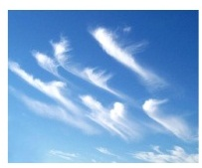

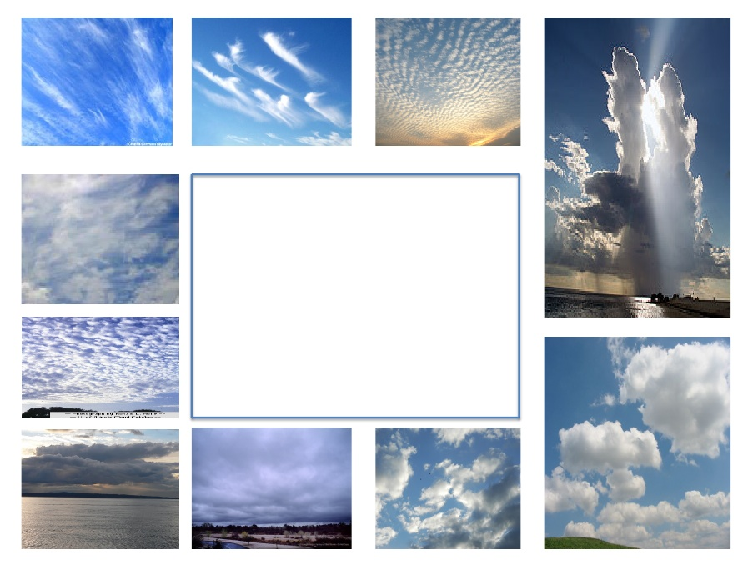

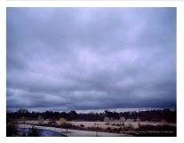

**Cut this piece out**

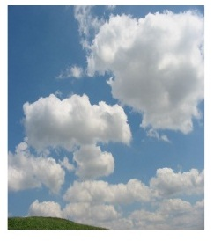

**cirrus**

**stratus**

**cumulus**