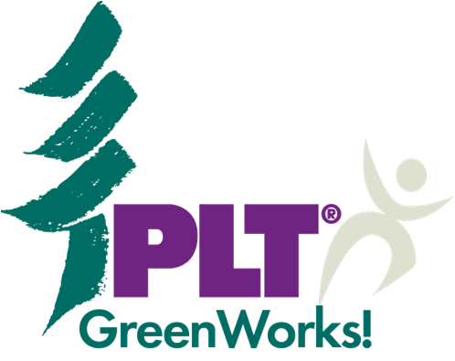
2016 Grant Application

Project Learning Tree®, a national PreK-12 environmental education program, is offering GreenWorks! grants up to $1,000 to schools and youth organizations for environmental service-learning projects that link classroom learning to the real world. Students implement an action project they help design to green their school or to improve an aspect of their neighborhood’s environment.

Project proposals are due September 30th, 2016, and funds will be distributed in December for project implementation throughout the 2017 calendar year. To apply for a PLT GreenWorks! service-learning grant, please complete this form in its entirety.

Submission Instructions: Submit your completed application and W-9 online. Login or create an account, click “Apply for a Grant,” then follow the prompts to complete your submission. You will receive an automatic confirmation email through this system. If you have any questions please contact information@plt.org. Emailed applications will not be considered.
Part I: Applicant Information

Contact Name

Title

School/Organization Name

School/ Organization Address

City State Zip

Email Phone

My institution is a:

- Public School
- Private School
- Charter School
- Nature Center
- Student Club
- Community Based Organization
- Before or After School Program
- Other:______________________

Part II: Fiscal Agent Information

If you are awarded a GreenWorks Grant, to whom should the check should be made payable?

______________________________________________________________________________
(Please tell us the name of the fiscal agent, or organization that will receive your funding. This should be your school or your school’s PTO/PTA. If you are requesting a third party receive your funds, please explain why in a separate letter attached to your application. Funds must be distributed to an organization and not an individual.)

Fiscal Agents Tax ID Number (Use Format XX-XXXXXXX):
(Please provide the employer identification number (EIN), taxpayer identification number (TIN),
federal identification number, or similar for the organization receiving your grant funding.)
Fiscal Agent’s IRS code section (for tax exempt entities)
Example: 501(c)(3)
REMEMBER TO SUBMIT YOUR W-9 FORM!
As mandated by Project Learning Tree’s auditing procedures, all applicants must submit a W-9 form for the entity that will receive their grant funding. You can visit the Internal Revenue Service website to download a W-9 Form. Please save, complete, and submit the W-9 Form electronically, along with this grant application. If you do not submit the W-9, your application will be considered incomplete and will not be eligible for funding.

Part III: Grant Requirements
Note: You must answer Yes to all of the following questions to be eligible for funding.

Enter Yes or No

- Have you attended a Project Learning Tree (PLT) workshop?
If in-person, indicate the state and year:
If online, indicate the course:
(Note: Only PLT’s PreK-8 and Early Childhood Online Courses meet the eligibility requirements.)
PreK-8: Early Childhood:

- Is this project a service-learning experience?

- Does this project involve local community partners?

- Have you secured 50 percent matching funds for your project?
(some of which may be in-kind services/time)

Part IV: Project Overview

- Project Title:

- Project Type (e.g. school recycling, site restoration, energy conservation, etc.):

3. Grade level(s) involved:

4. Number of students involved:

5. Project Abstract: Briefly describe your project using 100 words or less.

6. Amount requested: $ Acquired matching funds: $

Part V: Project Narrative

- Describe your project that explains the logistics and details related to who, what, where, when, why, and how. Limit: 500 words

- Describe how your project exemplifies student voice. How will students be involved in the planning and implementation of the project? How will this project enhance student leadership skills? Limit: 250 words

- Explain how the project exemplifies service-learning through its connection to academic curricula. What community or school need does this project address? How will students learn from the project? How will this project be tied to academic content standards (if applicable)? What specific PLT activities will be used in the environmental education efforts that accompany this project? Limit: 250 words

- List and describe the role of community partner organizations involved in the project.
Limit: 250 words

- Provide a project timeline, which includes anticipated commencement and completion dates. Note: Funds will be distributed to awarded projects in December 2016. Limit: 250 words

- Describe your plan to share news about your project’s accomplishments. Limit: 250 words

Part VI: Budget

Use the table below to provide an itemized project budget. Note that funds may NOT be used to cover salaries, consulting fees, indirect administrative costs, shipping, electronic equipment, or field trip travel.

Expenses | Funds Requested | Matching Funds | Source of Matching Funds | Total  (Requested + Matching Funds)
 | $ | $ |  | $
 | $ | $ |  | $
 | $ | $ |  | $
 | $ | $ |  | $
 | $ | $ |  | $
 | $ | $ |  | $
 | $ | $ |  | $
 | $ | $ |  | $
 | $ | $ |  | $
 | $ | $ |  | $
 | $ | $ |  | $
 | $ | $ |  | $
 | $ | $ |  | $
TOTALS | $ | $ |  | $

